A Project Report On

**Job Portal Website**

Submitted in partial fulfillment of the requirement for the award of the degree

MASTER OF COMPUTER APPLICATIONS

(M.C.A.)

Academic Year 2023 – 24

**Yamunesh Patadia (92200584028)**

|  |
| --- |
| **Internal Guide** |
| Dr. Kalpesh Popat |



Rajkot-Morbi Road, At & PO : Gauridad, Rajkot 360 003. Gujarat. India.



**Faculty of Computer Applications (FCA)**



**This is to certify that the project work entitled**

**Job Portal Website**

**submitted in partial fulfillment of the requirement for**

**the award of the degree of**

**MASTER OF COMPUTER APPLICATIONS**

**(M.C.A.)**

**of the**

**Marwadi University**

**is a result of the bonafide work carried out by**

**Yamunesh Patadia (92200584028)**

**during the academic year 2023-24**

|  |  |  |  |  |
| --- | --- | --- | --- | --- |
| **Faculty Guide** |  | **HOD** |  | **Dean** |

**CERTIFICATE**

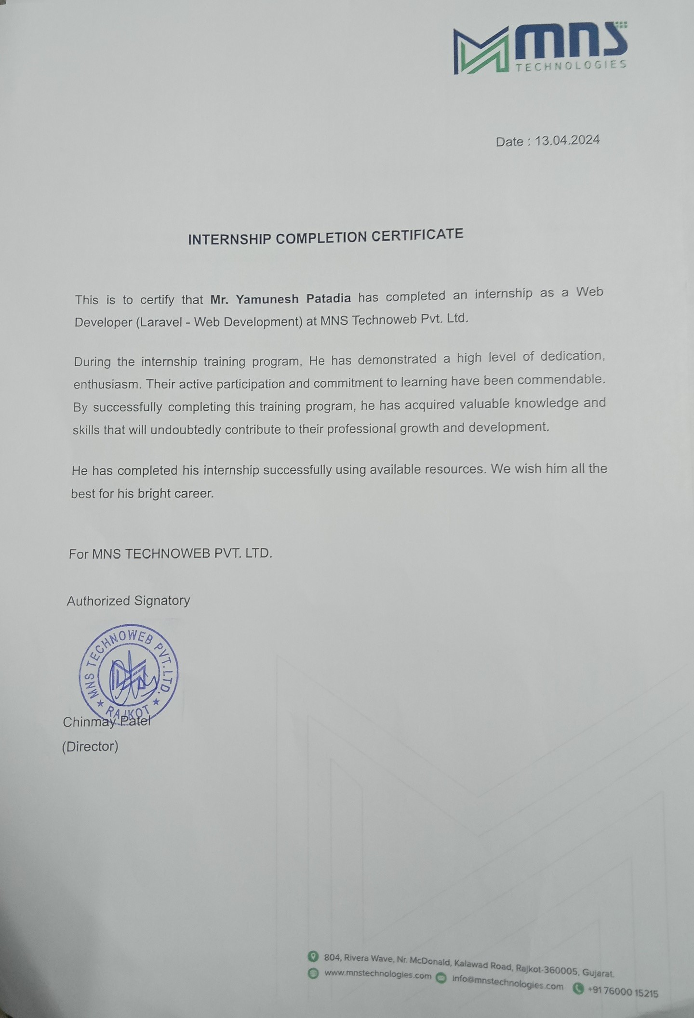

**DECLARATION**

I / We hereby declare that this project work entitled **Job Portal Website** is a record done by me/us.

I / We also declare that the matter embodied in this project is genuine work done by me / us and has not been submitted whether to this University or to any other University / Institute for the fulfillment of any course of study.

Place:

Date:

**Yamunesh Patadia (92200584028) Signature:**

**ACKNOWLEDGEMENT**

It is indeed a great pleasure to express my/our thanks and gratitude to all those who helped me/us. No serious and lasting achievement one can ever achieve without the help of friendly guidance and co-operation of so many people involved in the work.

I/We am/are very thankful to my/our faculty guide **Dr. Kalpesh Popat,** the person who makes me/us follow the right steps during project work. I/we express my/our deep sense of gratitude to his/her guidance, suggestions and expertise at every stage. Apart from that his/her valuable and expertise suggestion during documentation of my/our report indeed helped me/us a lot.

Thanks to my/our friends who have been a source of inspiration and motivation that helped me/us during my/our project work. I/we am/are heartily thankful to our external guide **Heena Trivedi** for providing me/us an opportunity to work over this report and for their endless and great support. I/we am/are also thankful to my/our Head **Dr. Sunil Bajeja** and Dean **Dr. R. Sridaran** for their support as and when required. I/we would like to extend my/our gratitude towards all who directly or indirectly supported and helped me/us to accomplish my/our project work.

**Yamunesh Patadia (92200584028) Signature :**

**COMPANY PROFILE**

MNS Technologies is a company that specializes in custom software development. They offer a variety of services including ERP software, mobile application development, website development, and IT consulting. They have a team of experienced developers and designers who are passionate about their work. MNS Technologies has a proven track record of success and has completed over 250 projects for clients in a variety of industries. They are committed to providing their clients with high-quality solutions that meet their specific needs.

MNS Technologies is a company that offers custom software development services. They specialize in ERP software, mobile application development, website development, and IT consulting. They have a team of experienced developers and designers who are passionate about their work. MNS Technologies has a proven track record of success, and their clients are very satisfied with their services.

* A brief history of the company
* The company's mission and vision statements
* The company's products and services
* The company's target market
* The company's competitive advantage
* The company's leadership team
* The company's awards and recognition
* The company's contact information

**CONTENTS**

|  |  |  |
| --- | --- | --- |
| **Chapters** | **Particulars** | **Page No.** |
| **1** | **SYNOPSIS** | 1-2 |
| **2**  2.1  2.2  2.3  2.4  2.5  2.6 | **PREAMBLE**  General Introduction  Statement of Problem  Objective and Scope of the Study  Module Description with functionality  Methodology  Feasibility Study | -  3  3  3  3  4  4 |
| **3** | **REVIEW OF LITERATURE** | 5 |
| **4**  4.1  4.2 | **TECHNICAL DESCRIPTION**  Hardware Requirement  Software Requirement | -  6  6 |
| **5**  5.1  5.2  5.3  5.3.1  5.4  5.4.1  5.4.2  5.4.3  5.5  5.5.1  5.5.2  5.6 | **SYSTEM DESIGN AND DEVELOPMENT**  Architectural Design / System Flow  Data Flow Diagram (DFD)  **Structural Modeling**   * Class Diagram   **Behavioral Modeling**   * Use Case Diagram * Sequence Diagram * Activity Diagram   **Database Design**   * Table Structure * Entity Relationship Diagram   Screen Design (Screen shots with short description) | -  7  8-9  -  10  -  11  12  13  -  14  15  16-19 |
| **6**  6.1  6.2  6.3  6.4 | **SYSTEM TESTING**  Testing and Implementation  Testing Methodology  Test Case Design  System Implementation Strategy | -  20  20  20  21 |
| **7** | **CONCLUSION** | 22 |
| **8** | **LEARNING DURING PROJECT WORK** | 23 |
| **9** | **FUTURE ENHANCEMENTS** | 24-25 |
| **10**  10.1  10.2 | **BIBLIOGRAPHY**  Online References  Offline References | -  26  26 |